**PIZZA SALES SQL QUERIES**

**A. KPI’s(Key Performance Indicator)**

**1. Total Revenue:**

select sum(total_price) as Total_Revenue from pizza; 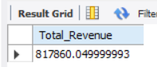

**2. Average Order Value**

select sum(total_price)/count(distinct order_id) as Avg_Order_Price from pizza;

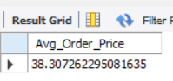

**3. Total Pizzas Sold**

select sum(quantity) as Total_Pizza_Sold from pizza;

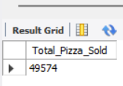

**4. Total Orders**

select count(distinct order_id) as Total_Orders from pizza;

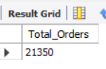

**5. Average Pizzas Per Order**

select cast(count(quantity)/count(distinct order_id) as decimal(10,2)) as Avg_Pizzas_Per_Order from pizza;

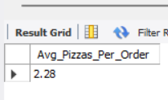

**B. Daily Trend for Total Orders**SELECT DAYNAME(order_date) AS order_day, COUNT(DISTINCT order_id) AS total_orders FROM pizza GROUP BY DAYNAME(order_date);

***Output:***

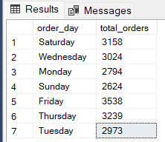

**C. Hourly Trend for Orders**

SELECT HOUR(order_time) AS order_hours, COUNT(DISTINCT order_id) AS total_orders FROM pizza GROUP BY HOUR(order_time) ORDER BY HOUR(order_time);

***Output***

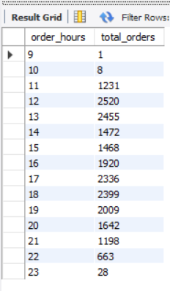

**D. % of Sales by Pizza Category**

SELECT pizza_category AS Pizza_Category, CAST(SUM(total_price) AS DECIMAL(10,2)) AS Total_Revenue, CAST((SUM(total_price) / (SELECT SUM(total_price) FROM pizza)) * 100 AS DECIMAL(5,2)) AS Percent_of_Sales

FROM pizza GROUP BY pizza_category;

***Output***

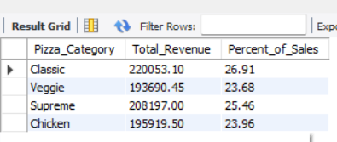

**E. % of Sales by Pizza Size**

SELECT pizza_size AS Pizza_Size, CAST(SUM(total_price) AS DECIMAL(10,2)) AS Total_Revenue,CAST((SUM(total_price) / (SELECT SUM(total_price) FROM pizza)) * 100 AS DECIMAL(5,2)) AS Percent_of_Sales FROM pizza GROUP BY pizza_size order by Percent_of_Sales desc;

***Output***

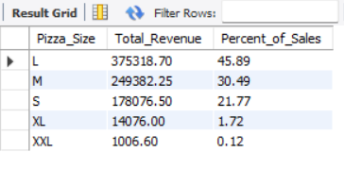

**F. Total Pizzas Sold by Pizza Category**

select distinct pizza_category, sum(quantity) as Total_Sales from pizza group by pizza_category;

***Output***

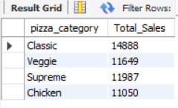

**G. Top 5 Best Sellers by Total Pizzas Sold**

select pizza_name as Pizza_Name , sum(quantity) as Total_Pizza_Sold from pizza group by pizza_name order by Total_Pizza_Sold desc limit 5;

***Output***

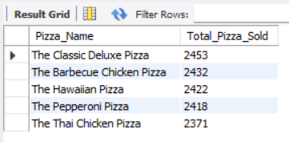

**H. Bottom 5 Best Sellers by Total Pizzas Sold**

select pizza_name as Pizza_Name , sum(quantity) as Total_Pizza_Sold from pizza group by pizza_name order by Total_Pizza_Sold limit 5;

***Output***

